Group Project 1

Jeremy Breese

Zachary Burkholder

Christina Roberts

Table of Contents

Use Case With Description

Activity Diagram #1

Activity Diagram #2

Activity Diagram #3

Class Diagram

Entity Relationship Diagram

Sequence Diagram

State Machine Diagram

Use Case Diagram

Created by: Christina

Reviewed by: Jeremy

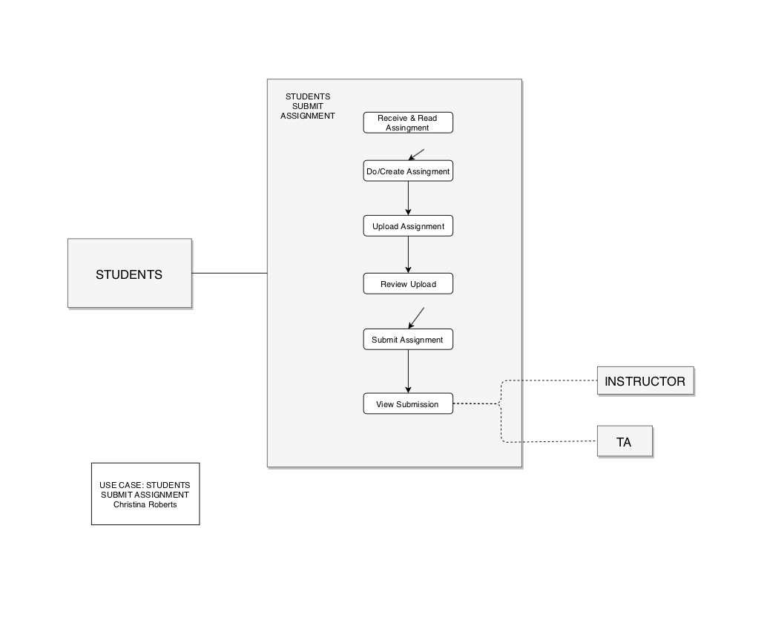

Activity Diagram #1

Created by: Jeremy

Reviewed by: Zachary

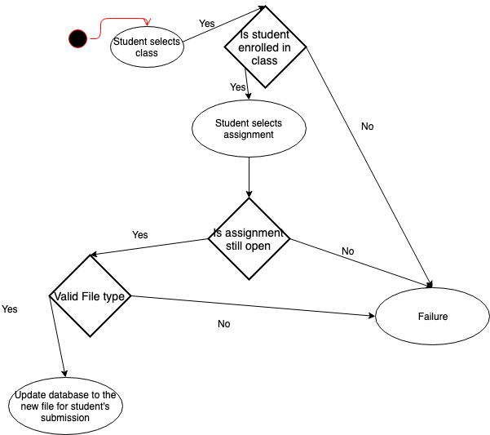

This diagram is for the student to resubmit an assignment. The activity checks that he student is enrolled in the course, that the assignment is still open, and that there is a valid file type.

Activity Diagram #2

Created by: Christina

Reviewed by: Jeremy

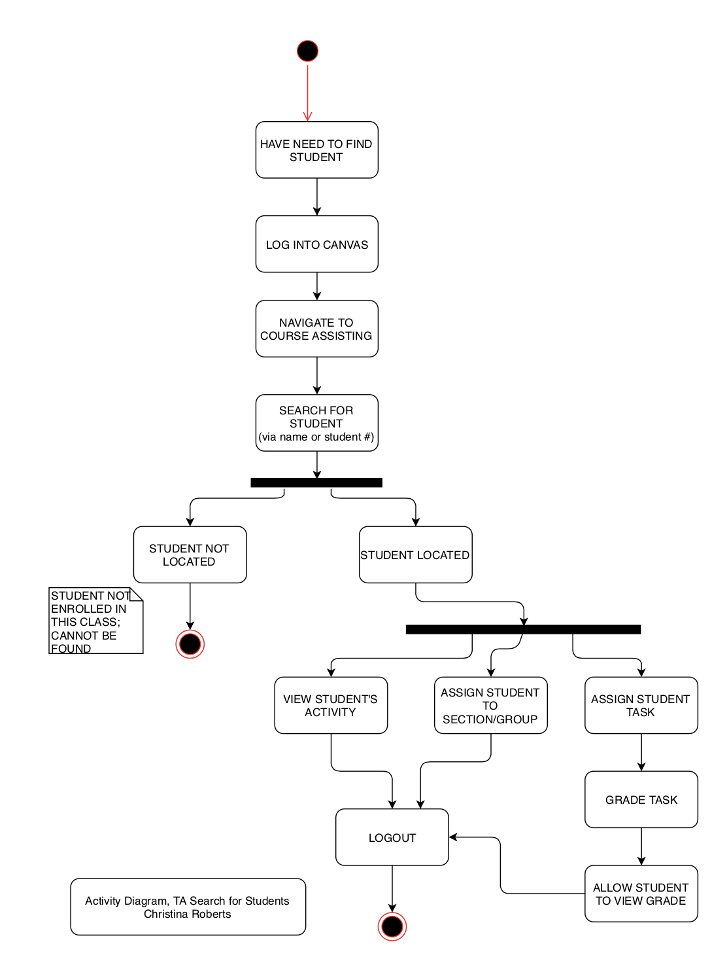

Activity Diagram #3

Created by: Zachary

Reviewed by: Christina

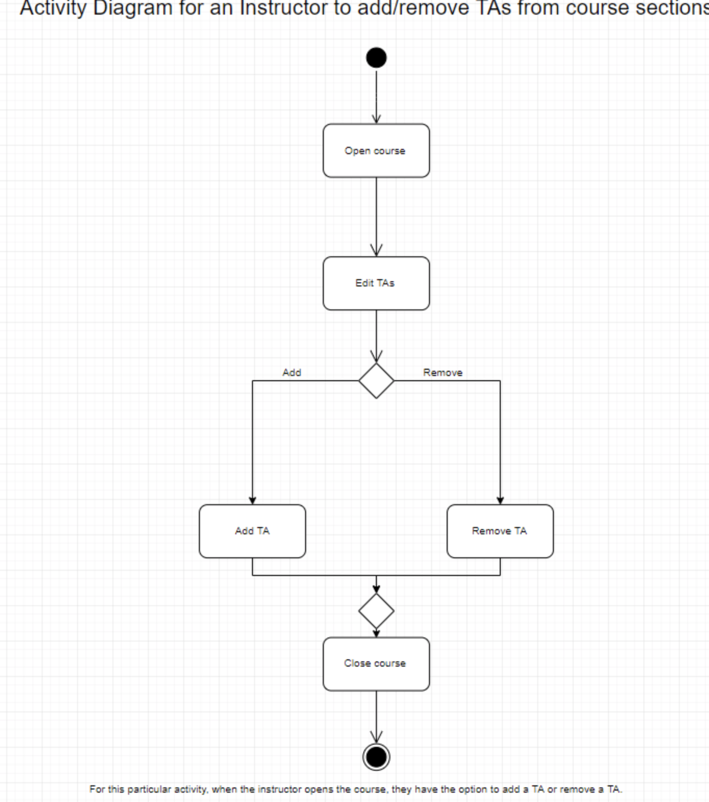

Class Diagram

Created by: Jeremy

Reviewed by: Christina

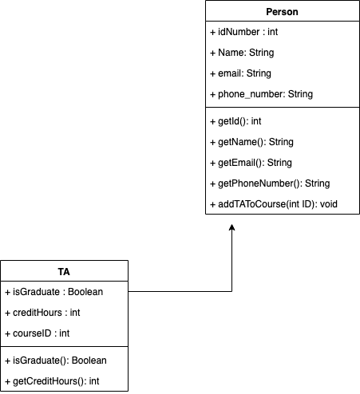

The class diagram is of a TA. The TA is a child class of a person.

Entity Relationship Diagram

Created by: Jeremy

Reviewed by: Zachary, Christina

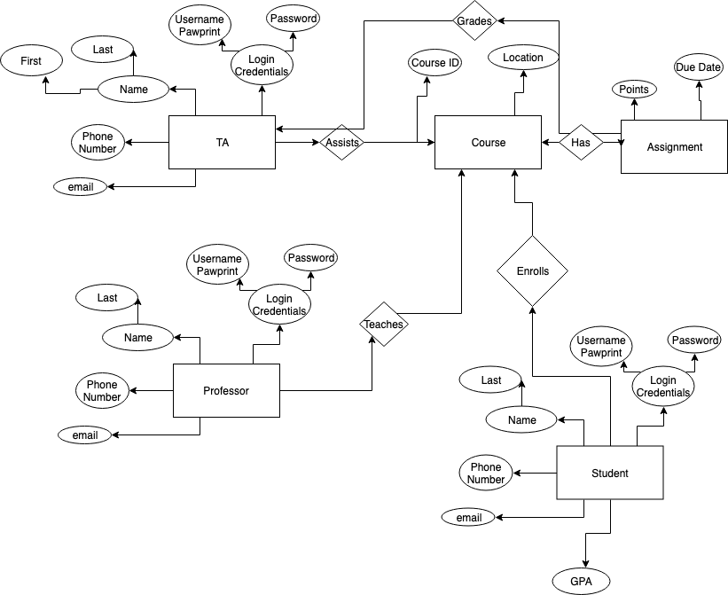

The ER Diagram shows each class, and how they interact with other classes. The classes are for professor, student, TA, course, and assignment.

Sequence Diagram

Created by: Zachary

Reviewed by: Jeremy

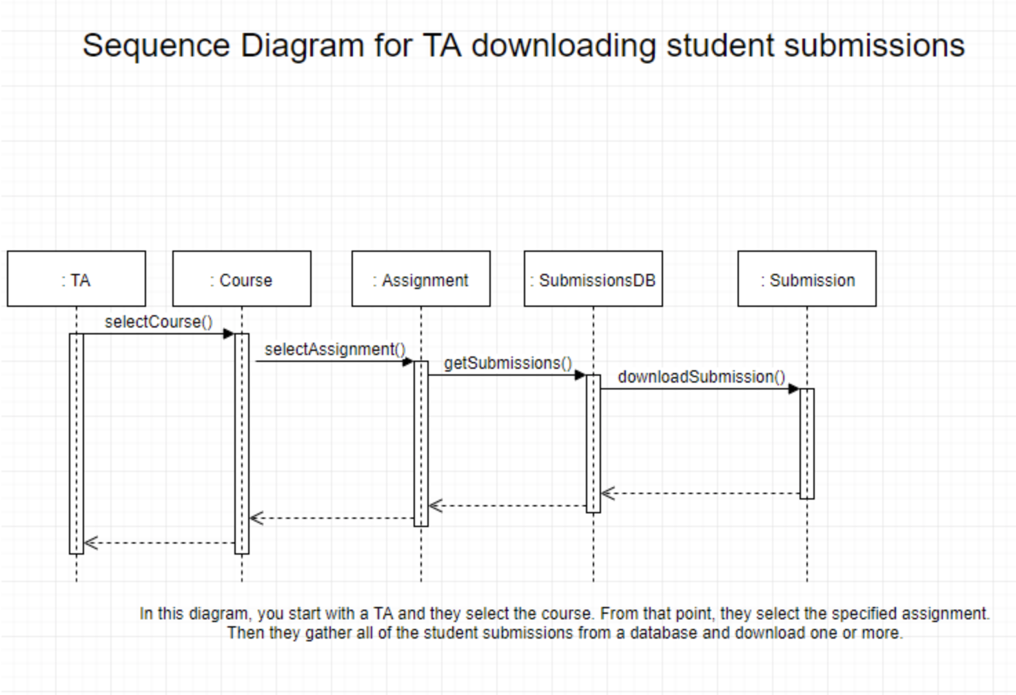

State Machine Diagram

Created by: Zachary

Reviewed by: Christina

